Secure Database Architecture

Ministry of Transport — Republic of Cameroon
Classification: RESTRICTED — Government Use Only
Reference: MOT-ISS-ARCH-2025-001 | Version 1.0 | May 2025
Compliance: Law No. 2024/017 on Personal Data Protection

Table of Contents
1. Overview & Design Philosophy
2. Network Architecture — The Invisible Database
  - 2.1 Why the Network Layer Matters
  - 2.2 Peer-to-Peer Mesh VPN with NetBird
  - 2.3 Mutual TLS (mTLS)
3. Storage & Data Security
  - 3.1 Encryption at Rest — Volume Level
4. Just-In-Time Access for Admins
  - 4.1 Why Permanent Credentials Are Dangerous
  - 4.2 The JIT Workflow with HashiCorp Vault & Boundary
5. Security Governance & Regulations
6. Global Architecture — Full System View
7. Scenario Analysis — Attack & Response Flows
  - 7.1 Scenario A: External Attacker Scans the Database Port
  - 7.2 Scenario B: Compromised Application Server
  - 7.3 Scenario C: Rogue Admin with Stolen Credentials
  - 7.4 Scenario D: Physical Disk Theft
  - 7.5 Scenario E: Legitimate Admin Debug Session
8. Implementation Roadmap
9. Limitations & Constraints

1. Overview & Design Philosophy
The Ministry of Transport database holds some of the most sensitive data in Cameroon: national identity linkages, driving licence records, vehicle ownership chains, and transport operator details. A breach does not only mean a data leak — it means potential identity fraud, falsified driving licences, and loss of public trust in government systems.

The architecture described in this document is built on a single governing principle:

Zero Trust, Data-Centric Security — assume the public internet is hostile, assume any single control can be bypassed, and design the system so that a breach of one layer reveals nothing useful to an attacker.

This is realised through four independent defence layers that stack on top of each other. An attacker must defeat all four simultaneously to reach plaintext data, which is practically infeasible:

Layer | What It Protects | Technology
L1 — Network Isolation | Makes the database invisible on the internet | Cloud Firewall + NetBird Mesh VPN
L2 — Transport Identity | Ensures only trusted apps can connect inside the VPN | Mutual TLS (mTLS)
L3 — Storage Encryption | Renders raw disk data unreadable without keys | LUKS FDE + TDE

Each layer is described in full detail below — what it is, why it is necessary, and exactly how it operates.

2. Network Architecture — The Invisible Database

2.1 Why the Network Layer Matters
The database server has a public IP address because it is hosted at a cloud provider. By default, this means that anyone on the internet can attempt to connect to it. Port scanners — tools that systematically probe IP addresses for open services — are run continuously by attackers around the world. If the database port (TCP 5432 for PostgreSQL) is visible, it will be found, and automated credential-stuffing and exploit attempts will begin within minutes.

The goal of the network layer is to make the database port completely invisible to the public internet while keeping it reachable only to the specific application servers that need it — even though those application servers live on different cloud providers.

The solution is a private encrypted overlay network built with NetBird, a modern Mesh VPN based on the WireGuard protocol.

2.2 Peer-to-Peer Mesh VPN with NetBird

What It Is
A Mesh VPN creates a virtual private network between a set of machines. Unlike traditional VPNs that route all traffic through a central gateway, a mesh VPN connects each machine directly to every other authorised machine in an encrypted peer-to-peer tunnel. NetBird uses WireGuard as its underlying protocol — a modern, audited, and extremely fast cryptographic VPN that operates over UDP.

Once the NetBird agent is installed on a machine, that machine receives a private overlay IP address (for example 100.64.0.x). Communication between machines in the mesh happens over this private address space, fully encrypted, regardless of where those machines are physically hosted.

Why We Need It
Without a Mesh VPN, the only way for an application server on Provider A to reach the database on Provider B is over the public internet using the database's public IP — which exposes it to every attacker on the internet.

With NetBird:

- The database port is bound only to the private overlay IP (e.g., 100.64.0.5), not to the public IP.
- The cloud firewall blocks all inbound traffic to the database except the WireGuard UDP handshake port (UDP 51820). There is no rule that opens TCP 5432 to anyone.
- An attacker scanning the database's public IP will find nothing open except the WireGuard port, which does not respond to unauthorized peers.
- Application servers authenticate with the NetBird management server using their public keys and are issued a private overlay IP. Only enrolled, authorised machines can join the mesh.

How It Functions — Step by Step
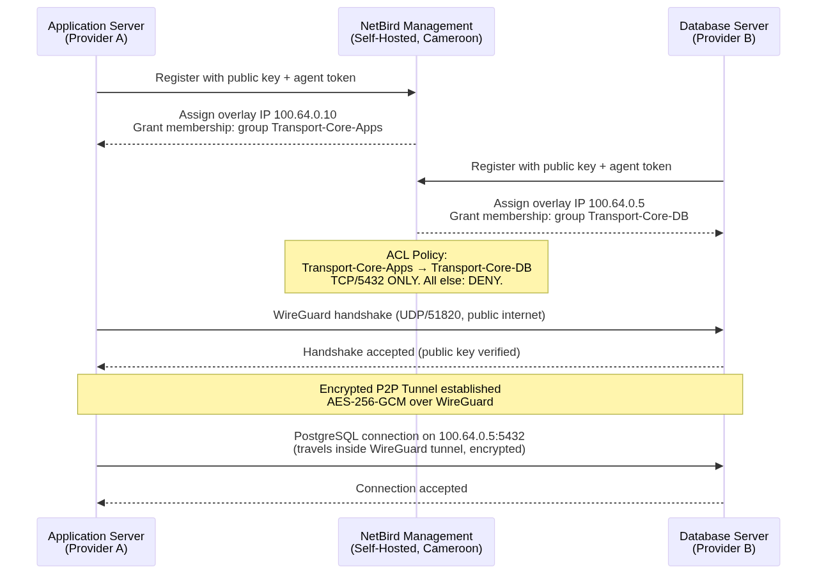

Network Access Control — ACL Policy
NetBird enforces rules at the management level. The following policy governs who can talk to the database:

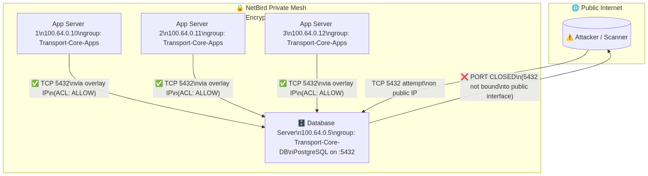

Result: The database is effectively invisible. Its public IP exists but carries no exploitable service on any standard port. The database lives in a shadow network that only enrolled, authenticated machines can see.

2.3 Mutual TLS (mTLS)

What It Is
TLS (Transport Layer Security) is the protocol that powers HTTPS — it encrypts a connection and lets a client verify the server's identity. Mutual TLS (mTLS) goes further: it requires both sides to present and verify a certificate. The server proves its identity to the client, and the client proves its identity to the server.

In the context of the database:
- The database (server) presents its certificate: the application knows it is talking to the real database, not an impersonator.
- The application (client) presents its certificate: the database knows it is talking to a trusted, registered application — not just any machine that happens to be inside the VPN.

Why We Need It
The VPN layer (NetBird) controls which machines can reach the database at the network level. But it does not control which processes or users on those machines can authenticate to the database.

Consider this attack scenario: an application server is compromised, and an attacker gets a shell on it. They are now inside the VPN and can reach the database IP. Without mTLS, they could attempt to connect with any username/password combination. With mTLS, they cannot connect at all without presenting the application's private certificate — which is stored in a protected secret store (HashiCorp Vault or an HSM), not on the filesystem.

mTLS provides cryptographic application identity. A certificate cannot be guessed or brute-forced.

How mTLS Works — Certificate Chain
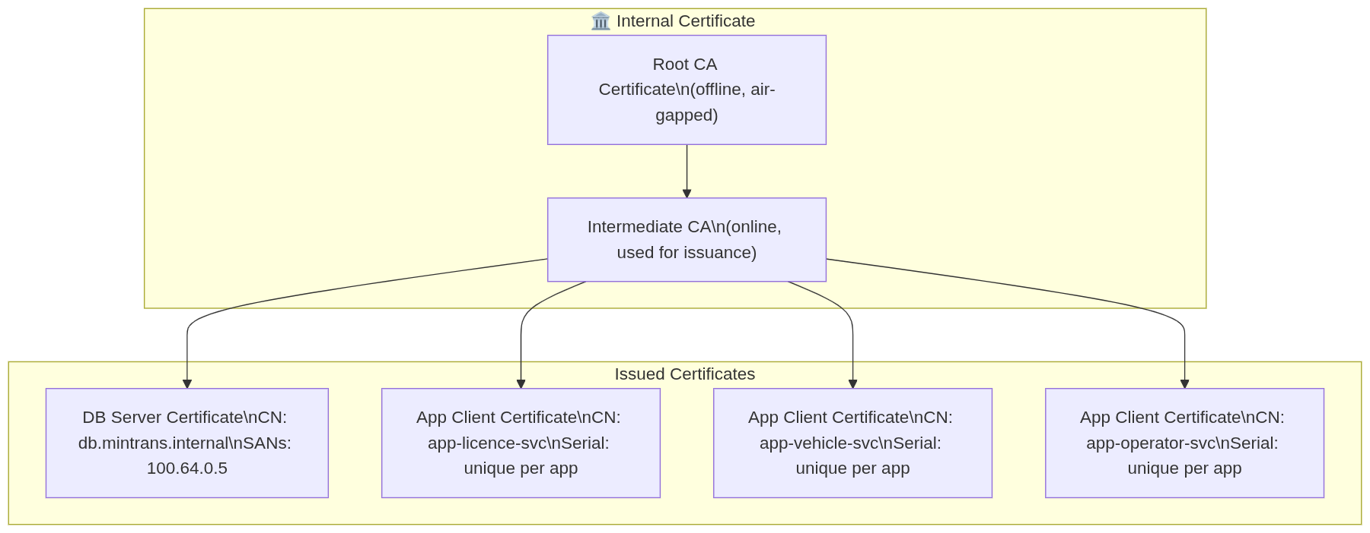

mTLS Handshake — Connection Flow
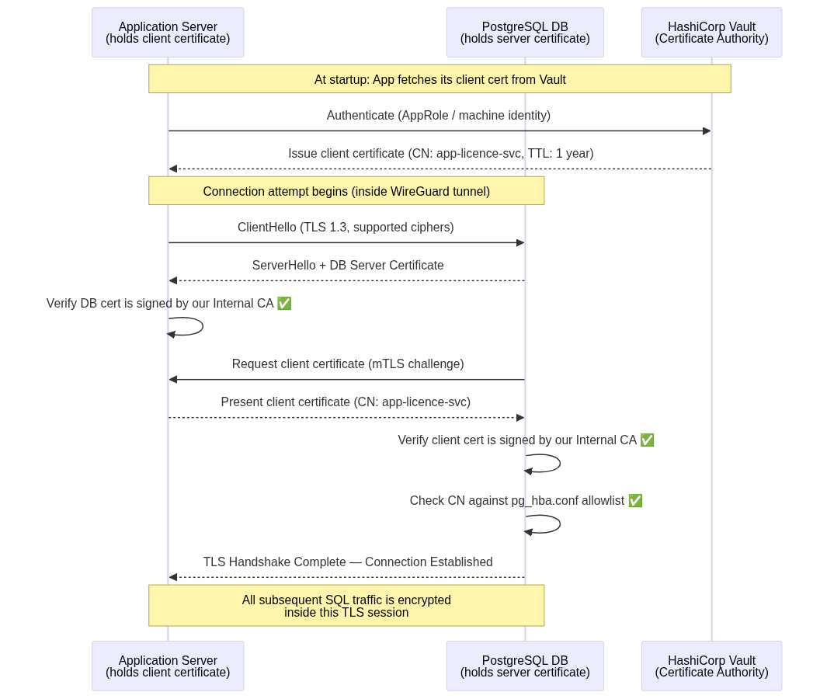

PostgreSQL Configuration
In pg_hba.conf, the database is configured to reject any connection that does not carry a valid client certificate:

# TYPE DATABASE USER ADDRESS METHOD
hostssl all app_licence_svc 100.64.0.0/24 cert clientcert=verify-full
hostssl all app_vehicle_svc 100.64.0.0/24 cert clientcert=verify-full
hostssl all app_operator_svc 100.64.0.0/24 cert clientcert=verify-full
# All other connection attempts are rejected
host all all 0.0.0.0/0 reject

Result: Even if an attacker gains access to the VPN network and knows a valid database username, they cannot connect without the private key of the corresponding client certificate. The certificate's private key never leaves the Vault or HSM.

3. Storage & Data Security
Securing the network pipe is essential, but it is not enough. If an attacker gains access to the physical disk (through provider compromise, datacenter breach, or confiscation), the data must still be unreadable. This section describes three complementary layers of data-at-rest protection.

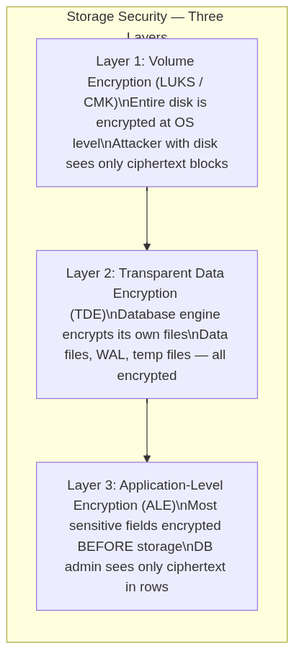

3.1 Encryption at Rest — Volume Level

What It Is
Volume encryption (Full-Disk Encryption / FDE) encrypts the entire storage volume at the block device level. Every byte written to disk — database files, logs, temp files, swap — is encrypted before it hits the physical medium. The encryption is handled by the OS kernel using LUKS (Linux Unified Key Setup) with the AES-256-XTS cipher.

Why We Need It
Cloud providers manage physical hardware. Their staff, legal processes in their jurisdiction, or a physical hardware recycling/replacement process could expose raw disk contents. Volume encryption ensures that the raw disk, if ever separated from the running system, is completely unreadable.

Additionally, Cameroon's Law No. 2024/017 on Personal Data Protection requires appropriate technical measures to protect personal data — volume encryption is the foundational technical measure.

How It Functions
When the system boots, it retrieves the LUKS decryption key from a secure key source (HashiCorp Vault's auto-unseal mechanism or a hardware HSM). The kernel decrypts disk reads and encrypts disk writes transparently. The PostgreSQL process, running on top, sees normal unencrypted data — but anything written to the physical medium is encrypted.

Customer-Managed Keys (CMK): If the cloud provider offers CMK, the master encryption key is held by the Ministry — not by the cloud provider. This means the provider cannot decrypt the volume even under a court order in their own jurisdiction. The Ministry retains full key sovereignty.

4. Just-In-Time Access for Admins

4.1 Why Permanent Credentials Are Dangerous
In traditional setups, administrators have a permanent database username and password. This creates several severe risks:

- Stale credentials — an admin who leaves the organisation may still have their credentials for days or weeks before anyone remembers to revoke them.
- Credential theft — a permanently valid password, if stolen, gives an attacker indefinite access.
- No blast radius control — a permanent admin account typically has broad privileges; a compromise of that account is a full breach.
- No forced audit trail — there is nothing forcing the admin's actions to be logged or reviewed before access is granted.

The solution is to eliminate all permanent human credentials to the production database. Humans access the database only through a Just-In-Time (JIT) system that generates short-lived, automatically-expiring credentials on demand.

4.2 The JIT Workflow with HashiCorp Vault & Boundary

The Components

Component | Role
HashiCorp Vault | Secret store and dynamic credential generator. Connects to PostgreSQL and creates/deletes temporary users on demand.
HashiCorp Boundary | Secure access broker. Controls who can request a session, enforces MFA, injects credentials into sessions (admins never see the password), and logs all activity.
NetBird Access Controls | The admin's machine is not in the Transport-Core-DB NetBird group by default — they cannot even reach the database IP unless a session is actively approved.
MFA | Multi-Factor Authentication (TOTP app + hardware key) is required to authenticate with Boundary before any credential can be issued.

The Full JIT Workflow
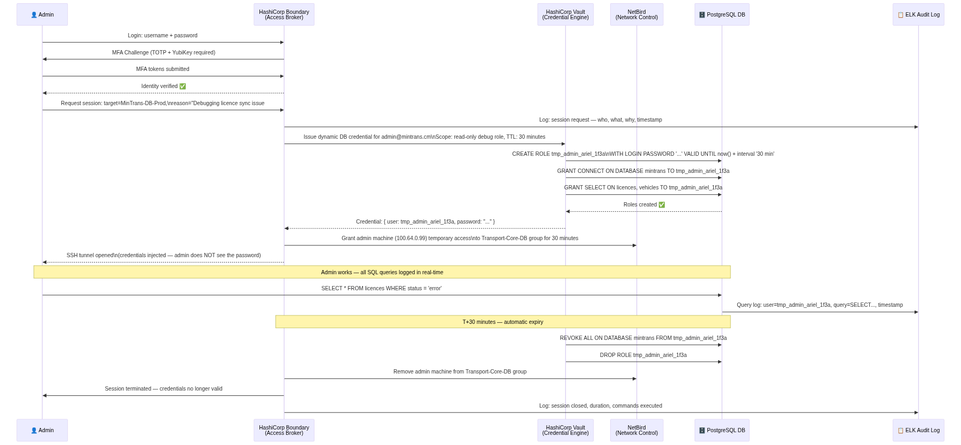

Access Permission Matrix

Actor | Network Access (NetBird) | DB Connection | Credential Type | TTL
Application servers | Permanent (group member) | mTLS client cert | Machine certificate | 1 year (auto-renew)
Senior admin | JIT only (session-scoped) | Boundary-injected password | Dynamic Vault user | 30 minutes
Junior admin / analyst | JIT only, read-only scope | Boundary-injected password | Dynamic Vault user | 15 minutes
Emergency break-glass | HSM-sealed envelope procedure | Direct (last resort) | Static + senior approval | Single use

Result: At any given moment, there are zero permanent human credentials in existence for the production database. If an admin's laptop is stolen, there is nothing to steal — the credentials expired 30 minutes after the last session ended.

5. Security Governance & Regulations

Audit Logging
Every single SQL statement executed on the production database is forwarded to a remote, immutable log server. This server is on a separate provider and separate network — a compromised database server cannot tamper with its own audit trail.

The pg_audit extension is configured to capture all DML (SELECT, INSERT, UPDATE, DELETE) and DDL (CREATE, ALTER, DROP) statements, along with the executing user, timestamp, and source IP.

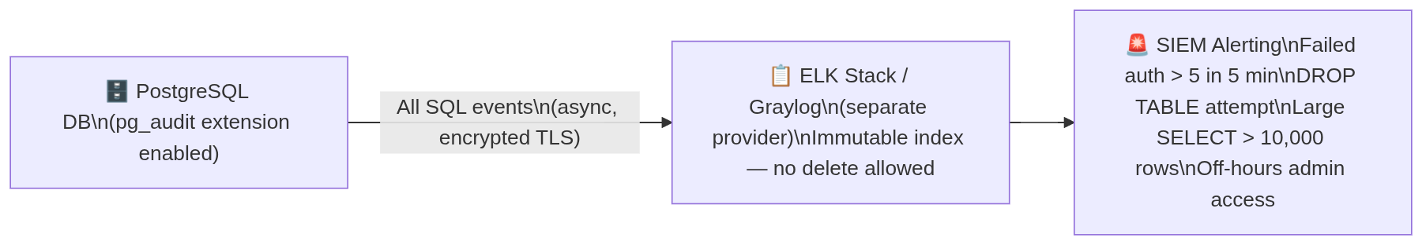

Principle of Least Privilege
No application user has any privilege beyond the minimum required for its function:

Application User | Allowed | Forbidden
app_licence_svc | SELECT, INSERT, UPDATE on licences.* | DROP, TRUNCATE, DELETE, EXPORT, pg_dump
app_vehicle_svc | SELECT, INSERT on vehicles.* | All writes beyond INSERT, DROP
app_report_ro | SELECT on reporting views only | All writes, schema access
app_operator_svc | SELECT, INSERT, UPDATE on operators.* | DROP, TRUNCATE, cross-schema access

Database Hardening

Hardening Measure | Implementation
Change default port | PostgreSQL listens on non-standard port (e.g., 54321) on the overlay IP only
Disable unused extensions | Remove all extensions not required by application
Non-privileged OS user | PostgreSQL process runs as postgres user, not root
Connection limits | Max connections per user enforced; rate limiting on pg_hba
OS hardening | CIS Benchmark Level 2 applied; SSH key-only, no password auth

IP Whitelisting — Secondary Failsafe
In addition to the NetBird overlay, cloud security groups are configured to allow the WireGuard port only from the known public IP ranges of the other cloud providers. This is a secondary, defence-in-depth measure — even if NetBird were to have a vulnerability, an attacker would also need to source their traffic from the correct provider IP range.

Data Residency & Legal Compliance (Law No. 2024/017)
- Physical servers hosting citizen personal data must be located within Cameroon or a jurisdiction with an adequacy agreement.
- All security tools (NetBird management, Vault, ELK) are self-hosted on Cameroonian or sovereign infrastructure — no government keys or logs pass through external SaaS platforms.
- Breach notification to the national data protection authority within 72 hours of detection.
- Data minimisation: applications must not use SELECT * — column-level grants enforce access to only necessary fields.

6. Global Architecture — Full System View
This diagram shows every component of the architecture and how they relate. Read it as three zones: the public internet (hostile), the NetBird private mesh (trusted but verified), and the security control plane (the nerve centre).

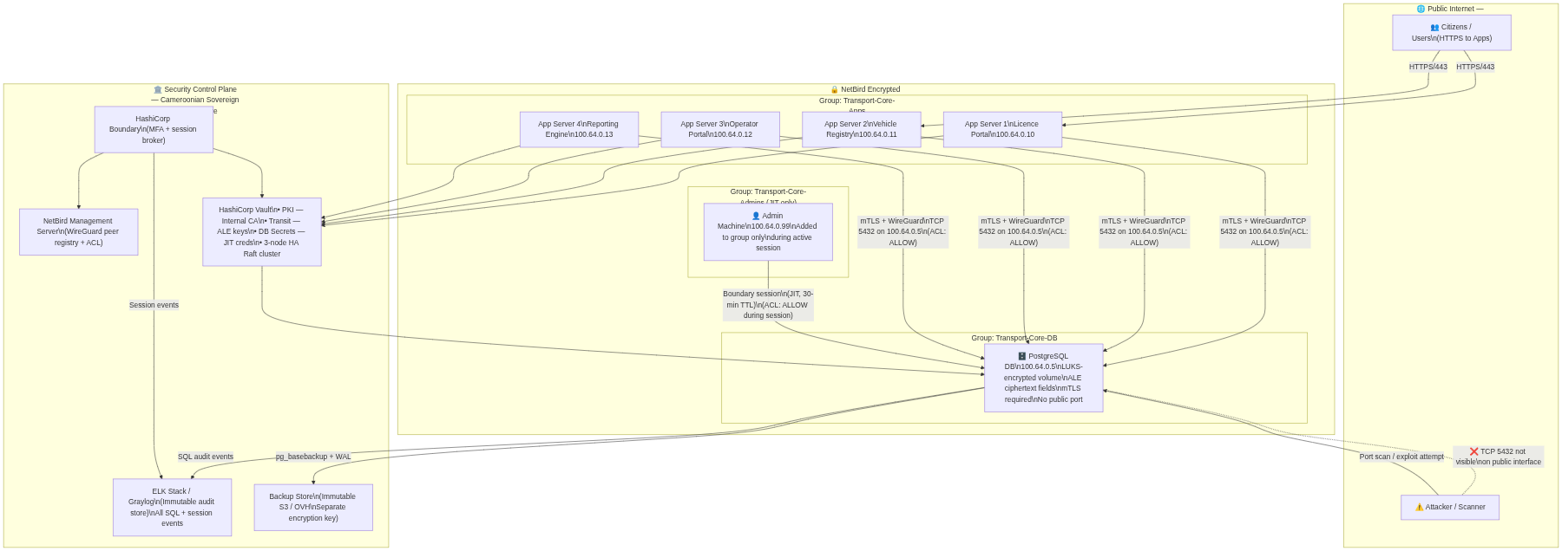

7. Scenario Analysis — Attack & Response Flows
This section walks through five concrete scenarios: four attack scenarios and one legitimate access scenario. Each shows how the architecture intercepts and neutralises the threat.

7.1 Scenario A: External Attacker Scans the Database Port
Threat: An attacker discovers the public IP of the database server and runs a port scan or attempts to connect to TCP 5432.

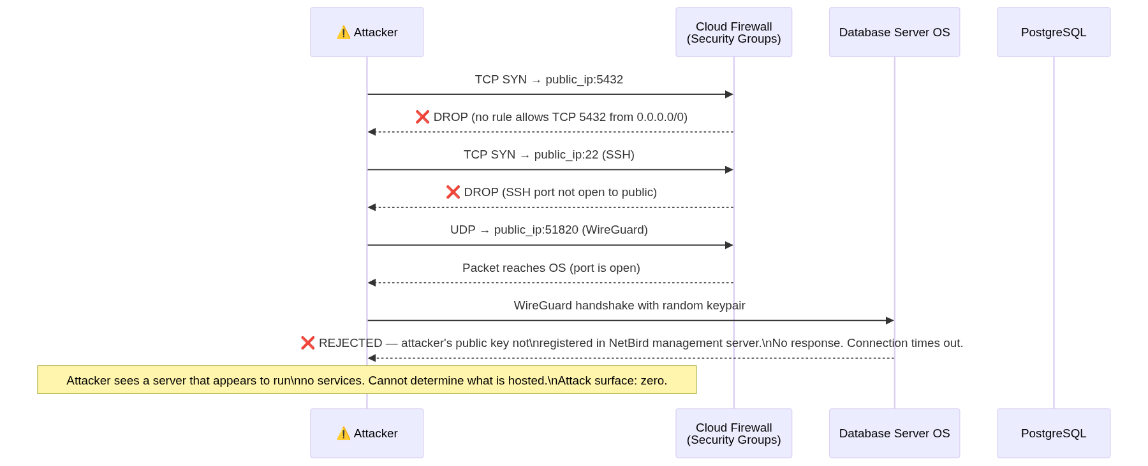

Outcome: The attack fails at the firewall. The attacker receives no information about what is hosted on the server. The event is not logged unless the WireGuard handshake is attempted (which is logged by NetBird management).

7.2 Scenario B: Compromised Application Server
Threat: An attacker exploits a vulnerability in one of the application servers (e.g., via a dependency with a known CVE) and gains a root shell on App Server 1.

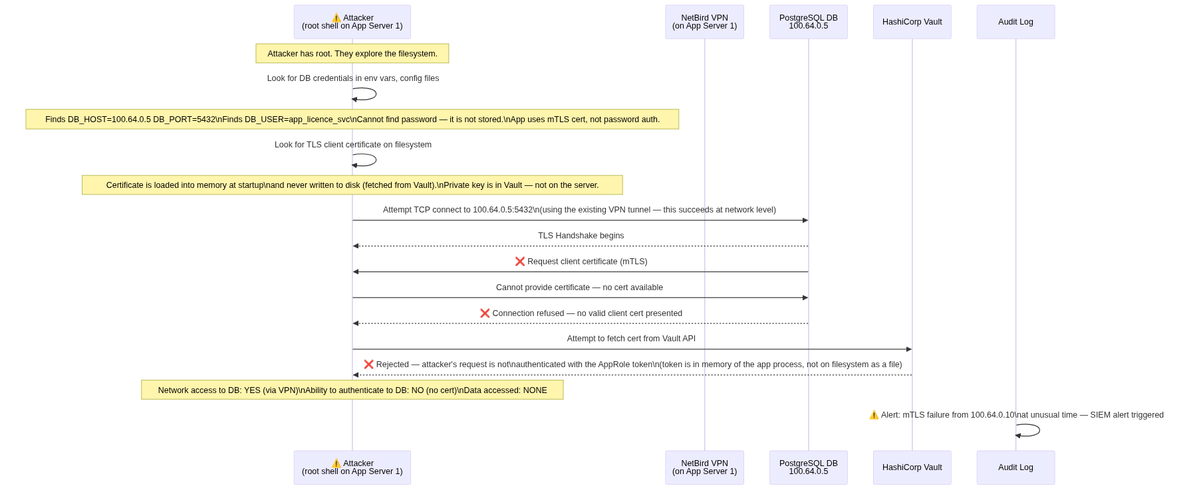

Outcome: The attacker reaches the database IP but is blocked by mTLS. No data is accessed. The failed mTLS handshake generates an alert in the SIEM. The blast radius is contained to App Server 1's own application data — no lateral movement to the database.

7.3 Scenario C: Rogue Admin with Stolen Credentials
Threat: A disgruntled or compromised admin still knows their Boundary login credentials and attempts to access the production database after hours or after their employment ends.

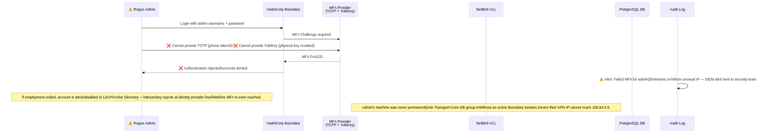

Outcome: The rogue admin is blocked at the MFA layer. Even if they somehow bypass MFA (which requires both a software token and a physical hardware key), they would also need to be added to the NetBird DB group — which only happens through an active Boundary session — and they would still face mTLS. Three independent blockers.

7.4 Scenario D: Physical Disk Theft
Threat: A cloud provider employee or datacenter intruder physically removes the database server's storage disk.

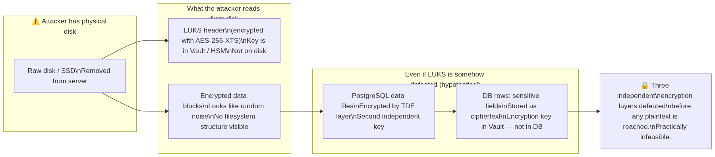

Outcome: The disk is useless without the LUKS master key, which never touches the disk. Three encryption layers stand between an attacker and plaintext citizen data.

7.5 Scenario E: Legitimate Admin Debug Session
Threat: None — this is the authorised workflow. Shown here to demonstrate that security controls do not obstruct legitimate operational needs.

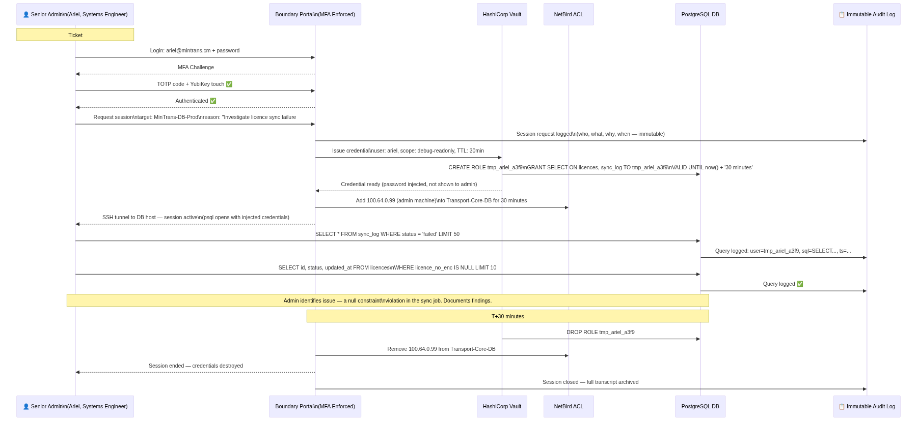

Outcome: The admin resolves the issue within 30 minutes. The session is fully logged. No credentials persist after session end. The admin never knew the database password.

9. Limitations & Constraints
No architecture is without trade-offs. The following constraints must be understood and mitigated operationally:

# | Limitation | Operational Impact | Mitigation
L1 | ALE adds per-field latency (~3–8ms per Vault Transit call) | High-frequency INSERT/SELECT throughput on encrypted fields may degrade 15–30% | Deploy Vault agent with local cache on each app server; batch encryption where possible
L2 | LUKS cannot encrypt a running volume without data migration | Planned downtime required at initial setup | Schedule a maintenance window; provision new encrypted instance and migrate data
L3 | 30-minute TTL may interrupt long-running admin operations (e.g., large index rebuilds) | Migration jobs may fail mid-execution if credential expires | Create a separate migration Vault policy with 4-hour TTL requiring two-person approval
L4 | NetBird management server is a single point of failure | If management server is down, new peer connections cannot be established (existing tunnels persist) | Run NetBird management in active-passive HA with automated failover
L5 | Vault HA is mandatory — a Vault outage blocks all new app connections and all JIT access | Full application downtime if Vault cluster is unavailable | 3-node Raft cluster; auto-unseal via cloud HSM (AWS KMS / Azure Key Vault)
L6 | ALE prevents server-side search on encrypted fields | LIKE '%CM-12345%' queries on encrypted columns will not function | Use Vault Transform secrets engine for deterministic tokenisation of searchable fields
L7 | LUKS master key loss = permanent data loss | If all Shamir shards are lost, the entire volume is permanently unrecoverable | Mandatory 3-of-5 Shamir ceremony; shards held by 5 different cleared senior officials in separate physical locations
L8 | Cameroonian infrastructure maturity — reliable Tier-3+ colocation may be limited in-country | Higher latency, fewer provider redundancy options | Evaluate Tier-3 data centres in Douala and Yaoundé; use WACS/ACE submarine cables for international path redundancy
L9 | mTLS certificate rotation requires coordination | Application restarts or rolling deployments needed when certificates are renewed | Vault's auto-renew capability handles rotation; applications must support SIGHUP-based cert reload without full restart
L10 | Complexity increases operational overhead | The security stack (Vault HA + Boundary + NetBird + ELK) requires trained staff to operate | Invest in training for at least 3 senior engineers; maintain detailed runbooks for every operational procedure

Document ends.

For implementation support, questions on specific configuration parameters, or a Proof-of-Concept setup guide for any individual component, refer to the respective tool's official documentation or contact the Directorate of Information Systems.

